
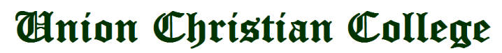

PROPERTY AND EQUIPMENT TRANSFER (PET) REQUEST
Dare Requested: TEP Request #:

Property Tag # | Qty. | Unit | Name and Description | Serial # | Location (From)  (Bldg/Office/Rm #) | Location (To)  (Bldg/Office/Rm #) | PAR # (From) | PAR # (To)

Purpose:

Turned Over by: Received by:
Name and Signature: |  |  | Name and Signature:
Position : |  |  | Position :
Office/Department : |  |  | Office/Department :

Attested by: Noted by:
RENEIR A. MANGAOANG  Supply and Property Custodian | RUFINA M. DUMAOANG, MAED  Administrative and Human Resource Development Officer and concurrent Supply and Property Officer
SIEGMUND RAY B. DE VILLA
General Services Supervisor

